**DAILY ONLINE ACTIVITIES SUMMARY**

|  |  |  |  |  |  |  |  |  |
| --- | --- | --- | --- | --- | --- | --- | --- | --- |
| **Date:** | **12-7-2020** | | | | | **Name:** | **poojashree** | |
| **Sem & Sec** | **8th sem A sec** | | | | | **USN:** | **4al16cs065** | |
| **Online Test Summary** | | | | | | | | |
| **Subject** | |  | | | | | | |
| **Max. Marks** | |  | | **Score** | | |  | |
| **Certification Course Summary** | | | | | | | | |
| **Course** | **Introduction to cyber security** | | | | | | | |
| **Certificate Provider** | | | **Great learning academy** | | **Duration** | | | **5.5hr** |
| **Coding Challenges** | | | | | | | | |
| **Problem Statement:** 1. python program for prefect sum | | | | | | | | |
| **Status:completed** | | | | | | | | |
| **Uploaded the report in Github** | | | | | **yes** | | | |
| **If yes Repository name** | | | | | **Poojashree** | | | |
| **Uploaded the report in slack** | | | | | **yes** | | | |

**Online test**

**----------no marks -----------**

**Certification course**

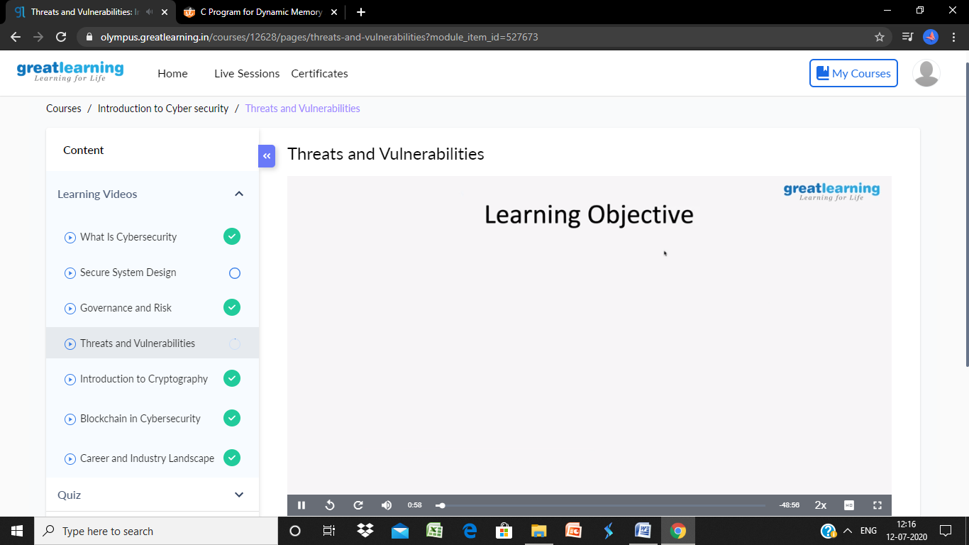

**Coding**

**Program 1**

def sumSubsets(sets, n, target) :

    x = [0]*len(sets);

    j = len(sets) - 1;

    while (n > 0) :

        x[j] = n % 2;

        n = n // 2;

        j -= 1;

    sum = 0;

    for i in range(len(sets)) :

        if (x[i] == 1) :

            sum += sets[i];

    if (sum == target) :

        print("{",end="");

        for i in range(len(sets)) :

            if (x[i] == 1) :

                print(sets[i],end= ", ");

        print("}, ",end="");

def findSubsets(arr, K) :

    x = pow(2, len(arr));

    for i in range(1, x) :

        sumSubsets(arr, i, K);

if __name__ == "__main__" :

    arr = [ 5, 10, 12, 13, 15, 18 ];

    K = 30;

    findSubsets(arr, K);